**Project Design Phase-II Technology Stack** **(Architecture & Stack)**

|  |  |
| --- | --- |
| DATE | 17 OCTOBER 2022 |
| PROJECT ID: | PNT2022TMID30346 |
| PROJECT TITLE: | AI-based Localization and Classification of Skin Disease with erythema |
| MAXIMUN MARKS: | 4 marks |

**Technical Architecture:**

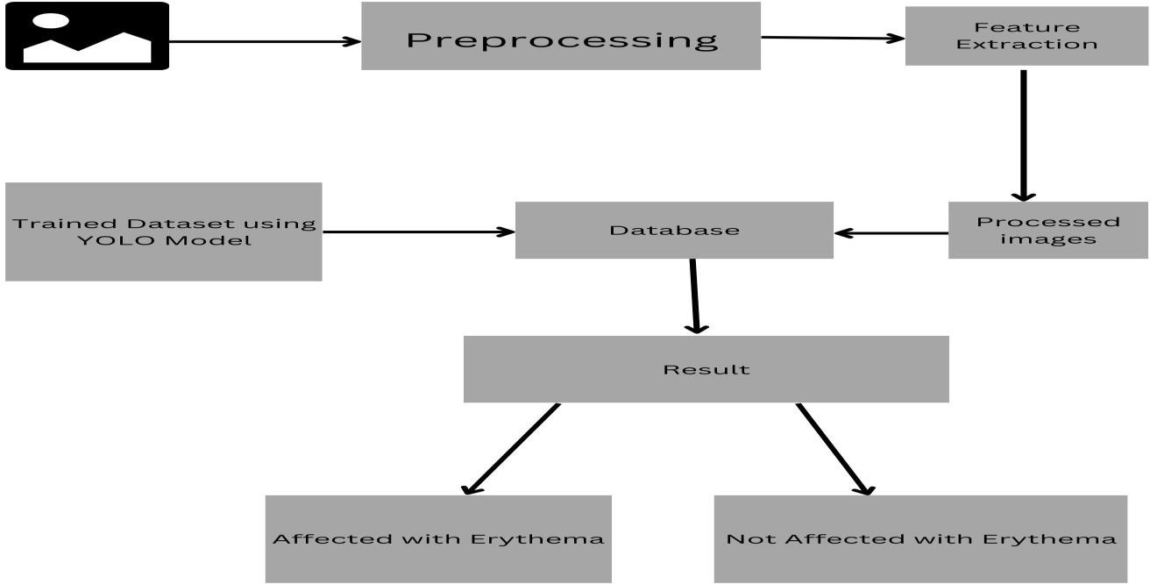

Table-1 : Components & Technologies:

|  |  |  |  |
| --- | --- | --- | --- |
| **S.No** | **Component** | **Description** | **Technology** |
| 1. | User Interface | How user interacts with application  e.g. Web UI, Chatbot etc. | HTML, CSS, JavaScript . |
| 2. | Application Logic-1 | Logic for a process in the application | Python |
| 3. | Application Logic-2 | Logic for a process in the application | IBM Watson Assistant |
| 4. | Cloud Database | Database Service on Cloud | IBM Cloudant |
| 5. | Machine Learning Model | Purpose of Machine Learning Model | Object Recognition Model |
| 6. | Infrastructure (Server / Cloud) | Application Deployment on Cloud Server Configuration : | Kubernetes |

Table-2: Application Characteristics:

|  |  |  |  |
| --- | --- | --- | --- |
| **S.No** | **Characteristics** | **Description** | **Technology** |
| 1. | Open-Source Frameworks | List the open-source frameworks used | Django |
| 2. | Security Implementations | List all the security / access controls implemented, use of firewalls etc. | Encryptions |
| 3. | Scalable Architecture | Justify the scalability of architecture (3 – tier, Micro-services) | 3-Tier Architecture |